**Project Design Phase-II**

**Data Flow Diagram & User Stories**

| Date | 27June 2025 |
| --- | --- |
| Team ID | LTVIP2025TMID31494 |
| Project Name | HealthAI:intelligent healthcare Assistant |
| Maximum Marks | 4 Marks |

**Data Flow Diagrams:**

**Here’s a Data Flow Diagram (DFD) for a Healthcare Assistant System, along with a list of important keywords you can use for reports, presentations, or documentation.**

**---**

**🧭 Data Flow Diagram: Intelligent Healthcare Assistant (Level 1)**

**+---------------------+**

**| Patient |**

**+---------------------+**

**|**

**| 1. Submit Symptoms / Requests**

**↓**

**+---------------------------+**

**| Healthcare Assistant App |**

**+---------------------------+**

**| | |**

**| | |**

**↓ ↓ ↓**

**+----------------+ +----------------+ +----------------+**

**| Symptom Check | | Appointment | | Medication |**

**| (AI analysis) | | Scheduler | | Reminder System|**

**+----------------+ +----------------+ +----------------+**

**| | |**

**| 2. Suggestions | 3. Booking | 4. Alerts**

**↓ ↓ ↓**

**+---------------- Results & Logs Saved ---------------+**

**---**

**📝 Important Words / Keywords**

**Category Keywords**

**📲 Functional Terms Symptom Checker, Appointment Booking, AI Chatbot, Virtual Consultation**

**🧠 AI Technologies NLP (Natural Language Processing), Machine Learning, Predictive Modeling**

**📈 System Components Patient Interface, Admin Dashboard, Data Logger, Emergency Alert Module**

**🧾 Data Types Patient Profile, Symptoms Input, Time Logs, Vitals Data**

**🏥 Healthcare Focus Diagnosis Support, Chronic Care, Remote Monitoring, Prescription Alert**

**🔒 Security & Compliance HIPAA, Data Encryption, Consent, Audit Logs**

**---**

**Would you like a visual DFD image of this structure?**

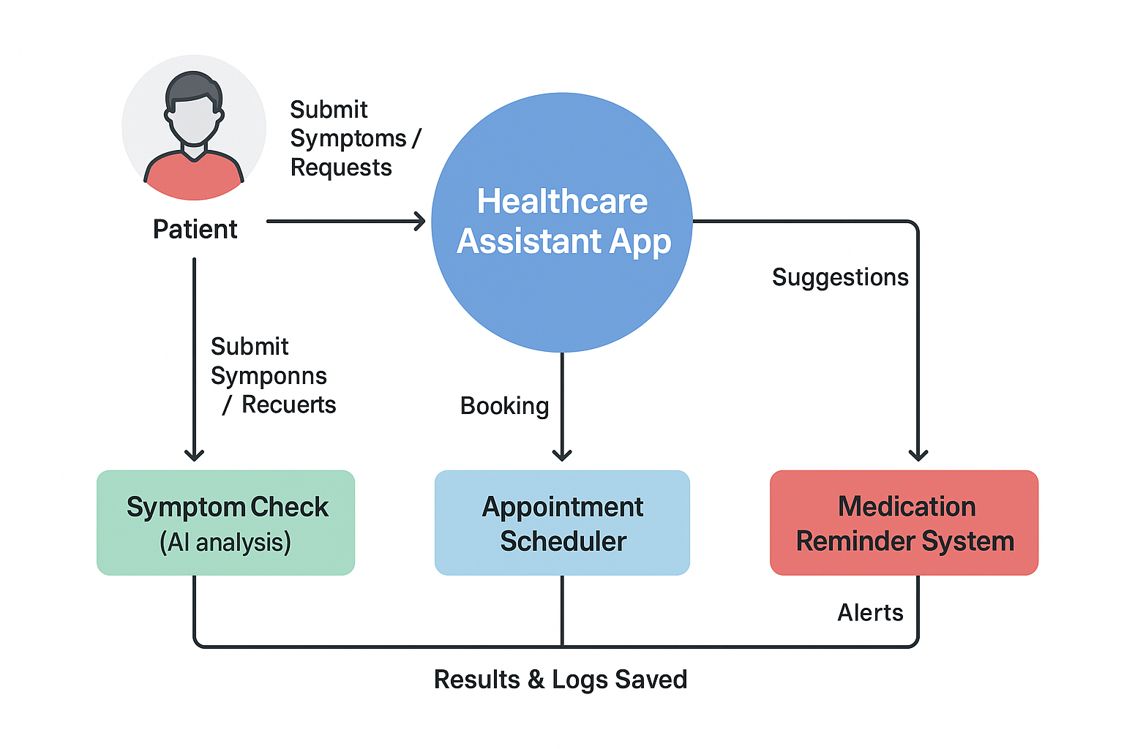

**+---------------------+**

**| Patient |**

**+---------------------+**

**|**

**| 1. Submit Symptoms / Requests**

**↓**

**+---------------------------+**

**| Healthcare Assistant App |**

**+---------------------------+**

**| | |**

**| | |**

**↓ ↓ ↓**

**+----------------+ +----------------+ +----------------+**

**| Symptom Check | | Appointment | | Medication |**

**| (AI analysis) | | Scheduler | | Reminder System|**

**+----------------+ +----------------+ +----------------+**

**| | |**

**| 2. Suggestions | 3. Booking | 4. Alerts**

**↓ ↓ ↓**

**+---------------- Results & Logs Saved ---------------+**

**User Stories**

Use the below template to list all the user stories for the product.

Here are examples of user healthcare stores – platforms, apps, or digital services where users can access healthcare products or services. These can be physical product stores, app-based platforms, or digital health ecosystems.

---

🛍️ Examples of User Healthcare Store

1. Tata 1mg – Online Pharmacy & Lab Tests – Buy medicines, book lab tests, doctor consultations, manage health records

2. Netmeds – Online Medical Store – Order prescription & OTC medicines, home delivery, health checkups

3. Practo – Healthcare Services Platform – Doctor booking, online consultations, pharmacy, digital health records

4. Apollo 24/7 – Hospital-backed Platform – Offers services linked to Apollo Hospitals, digital prescriptions, lab tests

5. Amazon Pharmacy – General Marketplace – Purchase medicines with prescription uploads, integrated with Amazon delivery

6. Apple Health Store – App Ecosystem – Health app downloads, sync wearables, manage and share health records

7. PharmEasy – eHealth Platform – Medicine ordering, diagnostic test booking, telemedicine services

---

🔑 Common Features in Healthcare Stores:

🧾 E-prescriptions & digital records

💊 Medicine delivery

🩺 Teleconsultation with doctors

🔬 Lab test booking

📱 Integration with wearables and health apps

💳 Digital payments and insurance linking

---